**Cosmetic Store Management**

**Submitted by** – Anupam Sharma

**Email** – anupamsharma8103@gmail.com

**1. Introduction**

**1.1 Project Overview**

This document outlines the project documentation for a Salesforce-based cosmetic store management system. The system is designed to streamline operations, provide valuable insights, and enhance decision-making for the cosmetic store.

**1.2 Project Objectives**

* Import and manage consultant data, including ConsultantName, DeliveryType, Products, and Payment details.
* Create reports to analyze consultant performance, delivery efficiency, product popularity, and payment trends.
* Develop interactive dashboards to visualize key metrics and trends.

**1.3 Project Scope**

The project scope includes the following key components:

* Data import and validation
* Report creation and customization
* Dashboard design and development

**2. System Requirements**

**2.1 Hardware Requirements**

* Sufficient computing power to handle data processing and reporting.
* Adequate storage capacity for data storage and backups.
* Internet connectivity for accessing Salesforce and external systems.

**2.2 Software Requirements**

* Salesforce platform with appropriate licenses and permissions.
* Data Loader for importing data into Salesforce.
* Report Builder for creating custom reports.
* Dashboard Builder for designing interactive dashboards.

**3. Data Import and Validation**

* Data Loader: Use Salesforce Data Loader to import data from external sources (e.g., spreadsheets, databases) into the custom objects.
* Data Validation: Implement data validation rules to ensure data integrity and consistency during import.

**4. Reporting and Analysis**

* Standard Reports: Utilize Salesforce's standard reports to analyze consultant data, including ConsultantName, DeliveryType, Products, and Payment details.
* Custom Reports: Create custom reports using Report Builder to address specific business needs.
* Report Types: Define report types to specify the objects and fields included in reports.

**5. Dashboard Development**

* Dashboard Builder: Use Salesforce's Dashboard Builder to create interactive dashboards.
* Dashboard Components: Utilize various components (e.g., charts, tables, metrics) to visualize data.
* Dashboard Filters: Apply filters to customize dashboard views based on specific criteria.

**Steps for Importing Data**

**To Import Data**

1. From Setup, click the Home tab.
2. In the Quick Find box, enter Data Import and select Data Import Wizard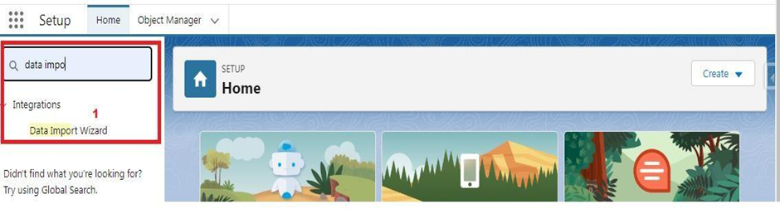
3. Click Launch Wizard!  
   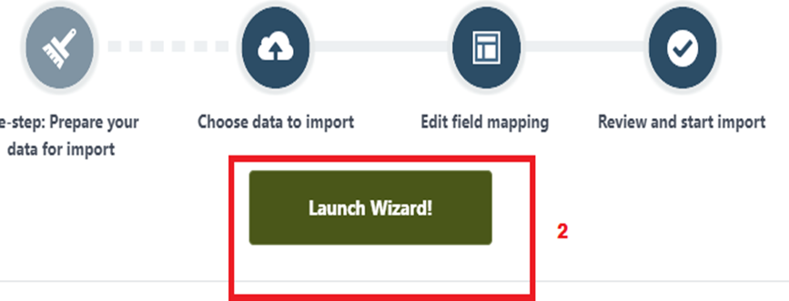
4. Click the Custom Objects tab and select the Consultant object.  
   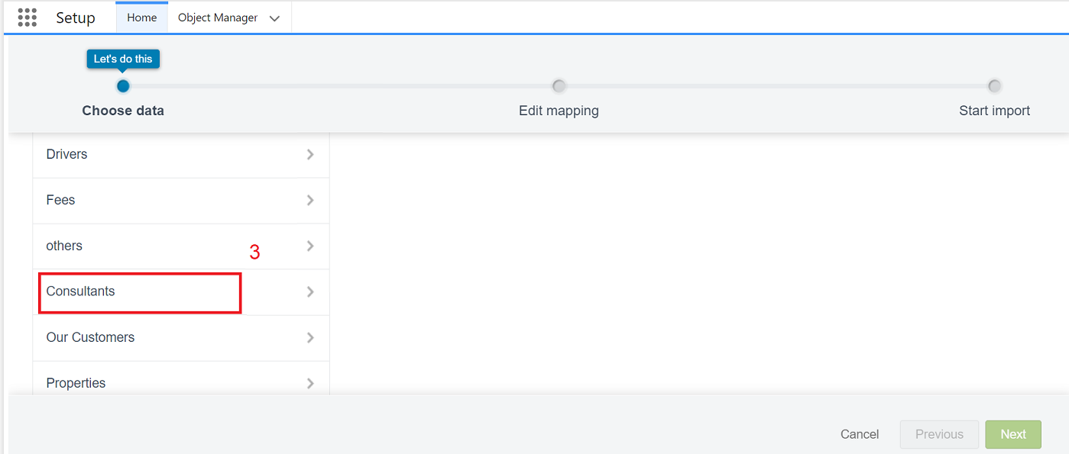
5. Select Add new records.  
   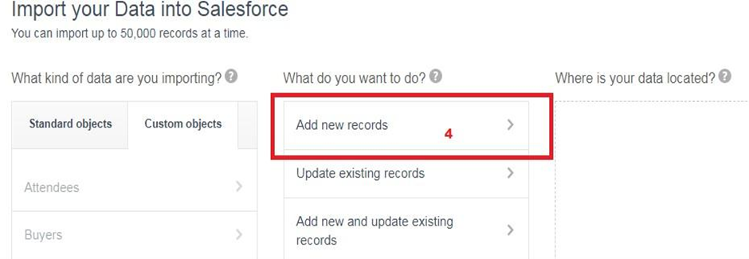
6. Click CSV and choose file Consultant_CSV which we made earlier. Click Next.  
   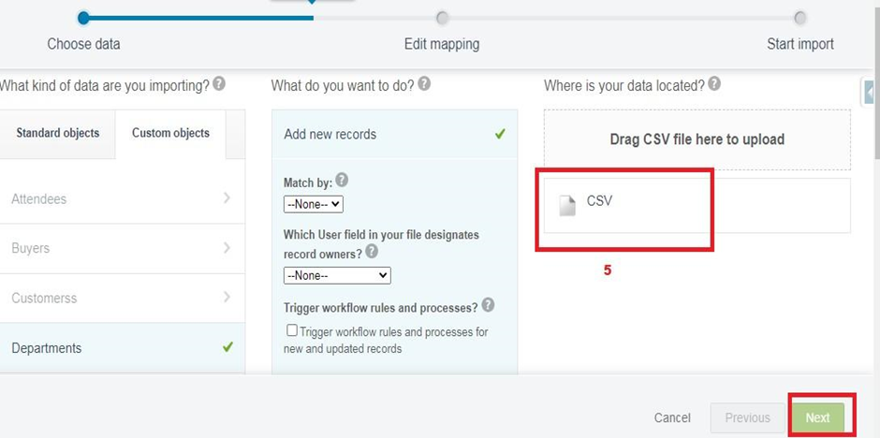
7. Since the field names in the CSV file (CSV Header) are the same as the field names in your object (Mapped Salesforce Object), the fields are automatically mapped. Click Next.  
   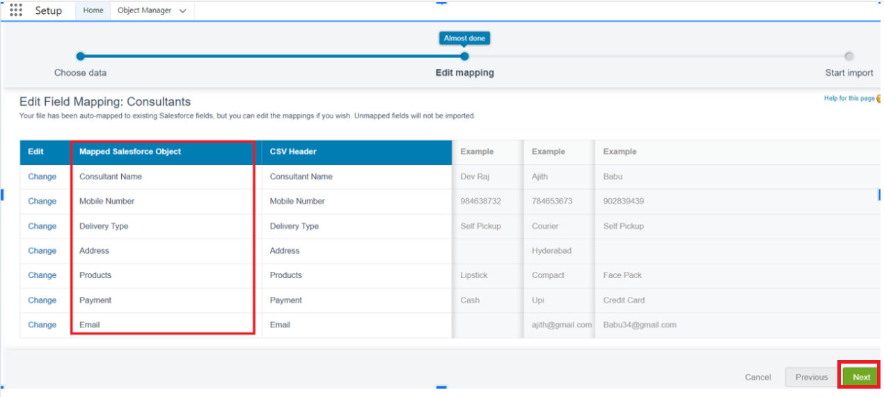
8. The next screen gives you a summary of your data import. Click Start Import.  
   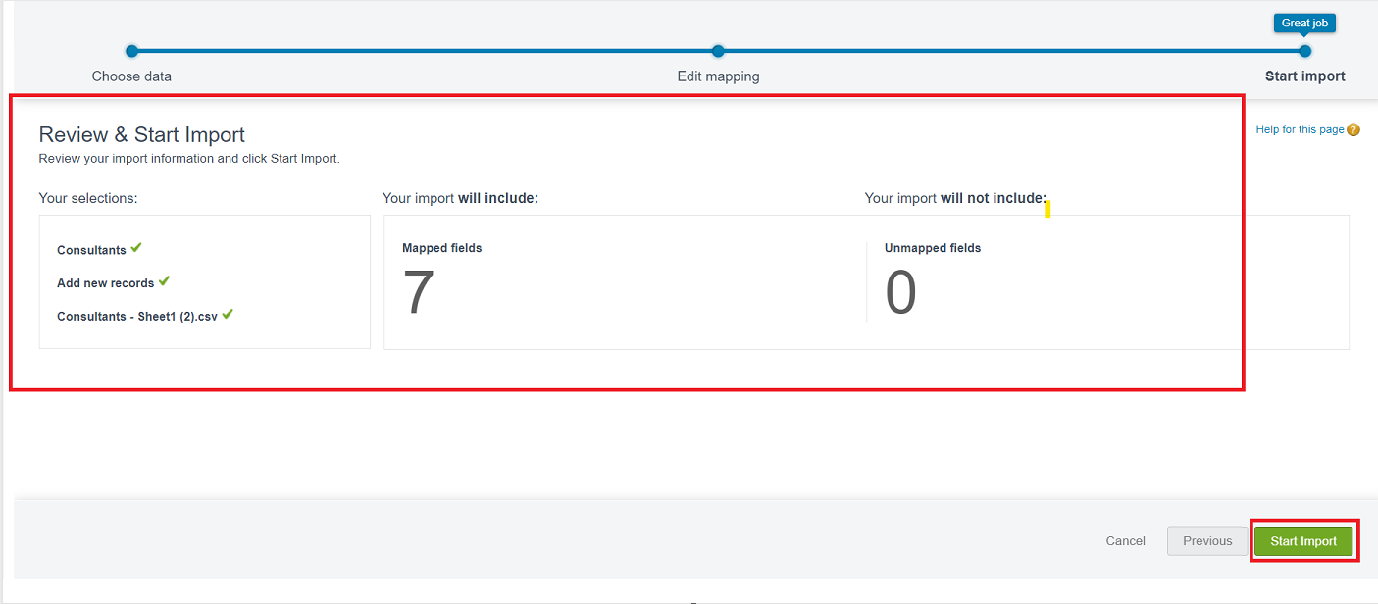
9. Click OK on the popup.  
   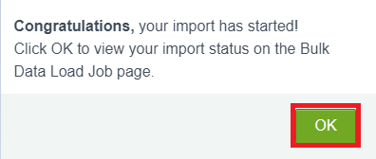
10. Scroll down the page and verify that your data has been imported under batches.  
    
11. Make sure you have 0 records under the records failed column.  
    **Note**- Do Field mapping carefully.

**Steps for Creating Report**

**Create Report**

1.Click App Launcher

2.Select Urban Color App

3.Click reports tab

4.Click New Report.

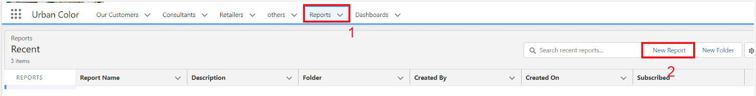

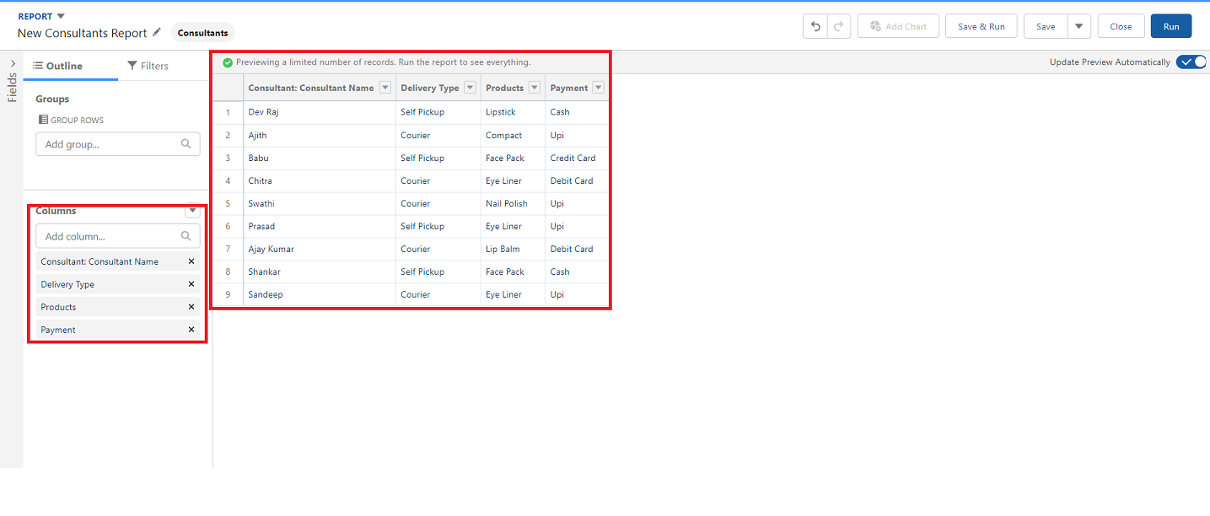

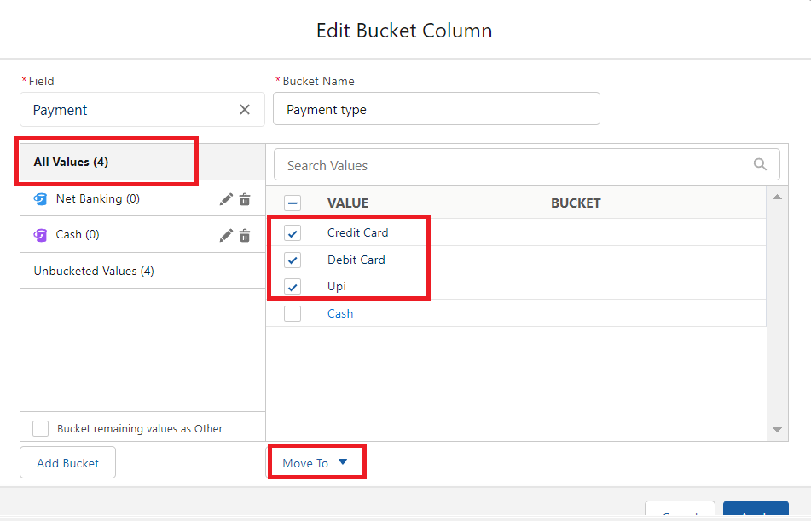

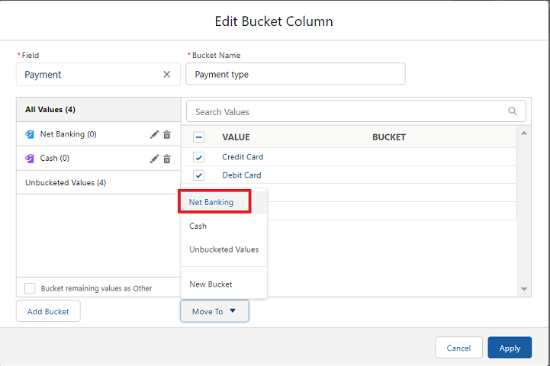

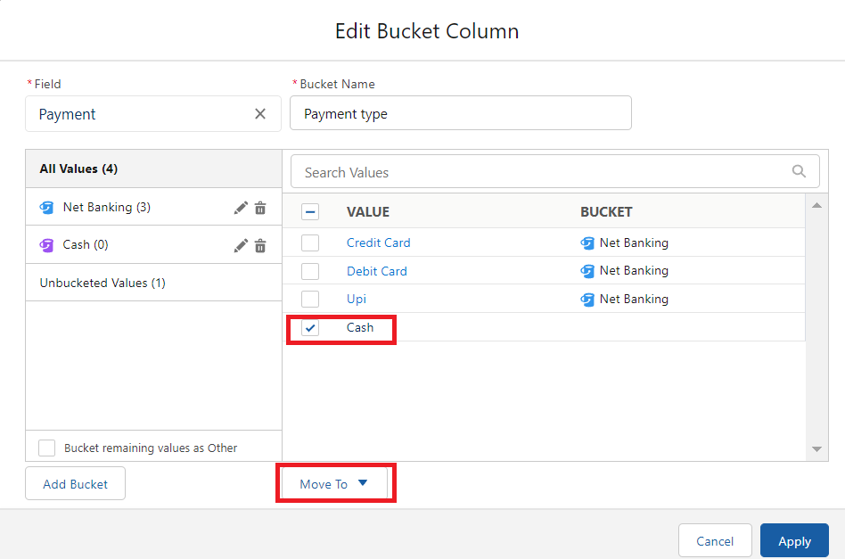

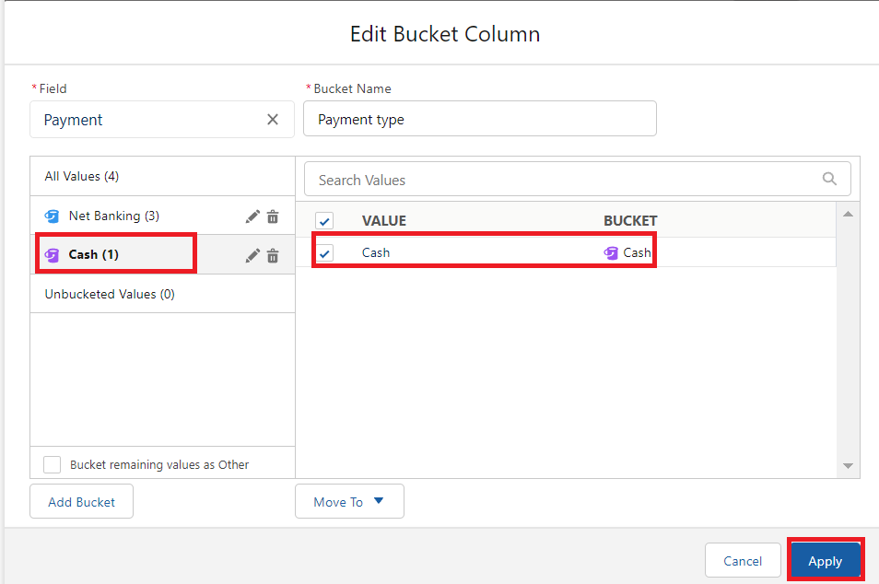

5.In Group Rows Add Payment Type Bucket Field.

6.Click refresh

7.Click Save and Run

8.Give report name – Consultant report

9.Click Save

**Steps for Creating Dashboard**

Create Dashboard

1. Click on the Dashboards tab from the Urban Color application.
2. Click on the new dashboard.
3. Give name- Consultant Dashboard
4. Click create

